

**NAVAL**

**POSTGRADUATE**

**SCHOOL**

**MONTEREY, CALIFORNIA**

**GROUND COMBAT VEHICLE SURVIVABILITY ROBUSTNESS ANALYSIS THROUGH MODEL BASED SYSTEMS ENGINEERING (MBSE)**

by

SE311-114G Vehicle Survivability

June 2013

Capstone Project Advisors: Dr. Douglas H. Nelson

Dr. Eugene P. Paulo

**CAPSTONE PROJECT REPORT**

**Distribution authorized to U.S. Government Agencies and their Contractors (Administrative or**

**Operational Use) (1 June 2012). Other requests for this document must be referred to President,**

**Code 261, Naval Postgraduate School, Monterey, CA 93943-5000 or RDECOM, Aberdeen Proving**

**Ground, Aberdeen, Maryland via the Defense Technical Information Center, 8725 John J. Kingman**

**Rd., STE 0944, Ft. Belvoir, VA 22060-6218.**

THIS PAGE INTENTIONALLY LEFT BLANK

|  |  |  |  |  |  |  |
| --- | --- | --- | --- | --- | --- | --- |
| **REPORT DOCUMENTATION PAGE** | | | | | *Form Approved OMB No. 0704-0188* | |
| Public reporting burden for this collection of information is estimated to average 1 hour per response, including the time for reviewing instruction, searching existing data sources, gathering and maintaining the data needed, and completing and reviewing the collection of information. Send comments regarding this burden estimate or any other aspect of this collection of information, including suggestions for reducing this burden, to Washington headquarters Services, Directorate for Information Operations and Reports, 1215 Jefferson Davis Highway, Suite 1204, Arlington, VA 22202-4302, and to the Office of Management and Budget, Paperwork Reduction Project (0704-0188) Washington DC 20503. | | | | | | |
| **1. AGENCY USE ONLY *(Leave blank)*** | | **2. REPORT DATE**  June 2013 | | **3. REPORT TYPE AND DATES COVERED**  Capstone Project Report | | |
| **4. TITLE AND SUBTITLE** **Ground Combat Vehicle Survivability Robustness Analysis through Model Based Systems Engineering (MBSE)** | | | | | **5. FUNDING NUMBERS** | |
| **6. AUTHOR(S)** David L. Basala, Louis W. Berklich, Christine K. Brennan, Steven P. Mazza, Joseph J. Rambousek, Donna A. Ray, Daniel Torres | | | | |
| **7. PERFORMING ORGANIZATION NAME(S) AND ADDRESS(ES)**  Naval Postgraduate School  Monterey, CA 93943-5000 | | | | | **8. PERFORMING ORGANIZATION REPORT NUMBER** NPS-SE-13-XX | |
| **9. SPONSORING /MONITORING AGENCY NAME(S) AND ADDRESS(ES)**  Department of the Army  U.S. Army Research, Development, and Engineering Command  3071 Aberdeen Blvd.  Aberdeen Proving Ground, MD 21005 | | | | | **10. SPONSORING/MONITORING**  **AGENCY REPORT NUMBER** | |
| **11. SUPPLEMENTARY NOTES** The views expressed in this thesis are those of the author and do not reflect the official policy or position of the Department of Defense or the U.S. Government. IRB Protocol number ______N/A______. | | | | | | |
| **12a. DISTRIBUTION / AVAILABILITY STATEMENT**  Distribution authorized to U.S. Government Agencies and their Contractors  (Administrative or Operational Use) (1 June 2012). Other requests for this document  must be referred to President, Code 261, Naval Postgraduate School, Monterey, CA  93943-5000 or RDECOM, Aberdeen Proving Ground, Aberdeen, Maryland via the  Defense Technical Information Center, 8725 John J. Kingman Rd., STE 0944, Ft.  Belvoir, VA 22060-6218 | | | | | **12b. DISTRIBUTION CODE**  C | |
| **13. ABSTRACT (maximum 200 words)**  Insert abstract here. | | | | | | |
| **14. SUBJECT TERMS** Model Based Systems Engineering, MBSE, Survivability, Ground Vehicle, Combat Vehicle, | | | | | | **15. NUMBER OF PAGES**  XXX |
| **16. PRICE CODE** |
| **17. SECURITY CLASSIFICATION OF REPORT**  Unclassified | **18. SECURITY CLASSIFICATION OF THIS PAGE**  Unclassified | | **19. SECURITY CLASSIFICATION OF ABSTRACT**  Unclassified | | | **20. LIMITATION OF ABSTRACT**  UU |

NSN 7540-01-280-5500 Standard Form 298 (Rev. 2-89)

Prescribed by ANSI Std. 239-18

THIS PAGE INTENTIONALLY LEFT BLANK

**Distribution authorized to U.S. Government Agencies and their Contractors (Administrative or Operational Use) (1 June 2012). Other requests for this document must be referred to President, Code 261, Naval Postgraduate School, Monterey, CA 93943-5000 or RDECOM, Aberdeen Proving Ground, Aberdeen, Maryland via the Defense Technical Information Center, 8725 John J. Kingman Rd., STE 0944, Ft. Belvoir, VA 22060-6218**

**GROUND COMBAT VEHICLE SURVIVABILITY ROBUSTNESS ANALYSIS THROUGH MODEL BASED SYSTEMS ENGINEERING (MBSE)**

SE311-114G Vehicle Survivability

David L. Basala; Louis W. Berklich Christine K. Brennan

Steven P. Mazza Joseph J. Rambousek Donna A. Ray

Daniel Torres

Submitted in partial fulfillment of the

requirements for the degree of

**MASTER OF SCIENCE IN SYSTEMS ENGINEERING**

from the

**NAVAL POSTGRADUATE SCHOOL**

**JUNE 2013**

Lead Editor: Louis W. Berklich

Reviewed By:

____________________ ____________________

Dr. Douglas H. Nelson Dr. Eugene P. Paulo

Capstone Project Advisor Project Advisor

Accepted By:

____________________

Cliff Whitcomb

Systems Engineering Department

THIS PAGE INTENTIONALLY LEFT BLANK

ABSTRACT

**GROUND COMBAT VEHICLE SURVIVABILITY ROBUSTNESS ANALYSIS THROUGH MODEL BASED SYSTEMS ENGINEERING (MBSE)**

**SE311-114G Vehicle Survivability–June 2013**

**Masters of Science in Systems Engineering**

**Advisor: Dr. Douglas H. Nelson Systems Engineering Department, Naval Postgraduate School**

**Advisor: Dr. Eugene P. Paulo Systems Engineering Department, Naval Postgraduate School**

THIS PAGE INTENTIONALLY LEFT BLANK

TABLE OF CONTENTS

I. INTRODUCTION 1

A. BACKGROUND 3

B. PROBLEM STATEMENT 4

C. RESEARCH QUESTIONS 4

D. Problem Space Boundaries 5

E. MBSE Methodology 6

F. Related Research 7

1. System of systems analysis toolset (SoSAT) 8

2. Capability Portfolio Analysis Tool (CPAT) 8

3. WSTAT 9

II. Process Development 11

III. Operational Analysis 15

A. Stakeholders 17

1. Stakeholder Identification 17

2. Stakeholder Analysis 18

B. Capability needs statement 19

C. Top level system functions and Requirements 19

D. Operational Concept and Scenario 21

1. Baseline Mission Scenario 21

2. Initial Order of Battle 22

3. Initial Force Disposition 23

4. Terrain and Red Force Composition and Disposition 23

E. Measures of Effectiveness and Measures of suitability 25

IV. Systems Architecture 27

A. Functional decomposition 31

B. Physical decomposition 31

V. Systems Analysis 32

VI. Model Development 35

A. Variables and Factors 38

1. Variables of Interest 38

2. Inputs and Outputs 38

VII. Model Execution 40

A. Analysis Tools 40

B. Design of Experiments Planning 42

a. Model Data References and Definitions 42

b. Factor Levels and Probability Distributions 42

c. Probability Model 42

d. Factorial Design 42

e. OMOE for Cost As Independent Variable 43

C. Simulations 43

1. Approach 43

a. Agent-based simulations 44

b. Map Aware Non-Uniform Automata (MANA) 44

c. Squad properties 45

2. Process 46

a. Nearly Orthogonal Latin Hypercubes 47

b. Baseline model 47

c. Non-materiel change configurations 50

VIII. Results 53

1. Regression Analysis and CAIV Results 53

2. Baseline Analysis 53

3. Alternative Configuration Analysis 53

XI. Summary and Recommendations 54

A. Challenges 54

B. Follow-on Work 54

1. Dashboard 54

2. Closer modeling of 2nd order effects 54

3. Investigation of emerging technologies 55

4. Broadening of the trade space 55

C. Recommendations 55

Appendix A: Reference Models for Simulations 56

Appendix B: Simulation Output Data 57

LIST OF REFERENCES 58

INITIAL DISTRIBUTION LIST 62

THIS PAGE INTENTIONALLY LEFT BLANK

LIST OF FIGURES

Figure 1 Army survivability project using MBSE process (from Professor Gene Paulo) 11

Figure 2 SoS SE elements and relationships (from (Systems Engineering Guide for Systems of Systems, 2008, p. 30) 12

Figure 3 MBSE process for ground systems survivability robustness 14

Figure 4 Stakeholder values 19

Figure 5 Initial order of battle 22

Figure 6 OV-1 Initial force disposition (after Treml) 23

Figure 7 Red force defensive positions (from (Treml)) 25

THIS PAGE INTENTIONALLY LEFT BLANK

LIST OF TABLES

Table 1 Stakeholders and users 16

THIS PAGE INTENTIONALLY LEFT BLANK

LIST OF ACRONYMS AND ABBREVIATIONS

**Acronym Definition**

AMC Army Materiel Command

AUTL Army Universal Task List

Bn Battalion

BoE Back of the envelope

CAB Combined Arms Battalion

CAP Corrective Action Plan

CDD Capability Development Document

CMP Configuration Management Plan

CONOPS Concept of Operations

DAG Defense Acquisition Guidebook

DM Data Management

DoD Department of Defense

DoE Design of experiment

DoDAF Depart of Defense Architecture Framework

DREN Defense Research and Engineering Network

EFP Explosively Formed Penetrators

FFBD Functional Flow Block Diagram

FER Force (or Fractional) Exchange Ratio

FOUO For Official Use Only

FRG Federal Republic of Germany

GCV Ground Combat Vehicle

GVSO Ground Vehicle Survivability Optimization

HOQ House of Quality

HQ Headquarters

IDEF Integration Definition for Function Modeling

IED Improvised Explosive Devices

IMS Integrated Master Schedule

IPT Integrated Product Team

JCIDS Joint Capabilities Integration Development System

MANA Map Aware Non-uniform Automata

MANPADS Man-portable air-defense systems

MBSE Model-based Systems Engineering

MBT Main battle tank

MCoE Maneuver Center of Excellence

METT-TC Mission, enemy, terrain troops and time and civil

MOE Measures of Effectiveness

MRAP Mine Resistant Armor Protected vehicle

M&S Modeling and Simulation

MSSE Masters Science Systems Engineering

NOLH Nearly orthogonal latin hypercube

NPS Naval Postgraduate School

OEM Original Equipment Manufacturer

OR Operations Research

OSP Operational Standard Procedure

PA Process Assurance

PL Programmatic Lead

PM Program Manager

PTL Project Team Lead

QFD Quality Functional Deployment

PEO CS & CCS Program Executive Office Combat Support and Combat Service Support

PEO GCS Program Executive Office Ground Combat Systems

RDECOM Research, Development and Engineering Command

RIA Rock Island Arsenal

ROI Return on investment

RPG Rocket Propelled Grenade

SAM Surface-to-Air Missile

S&T Science and Technology

SCAD Simulation Concept Architecture Design

SE Systems Engineering

SEED Simulation and Efficient Experimental Design

SE-WIPT Systems Engineering Working-level Integrated Product Team

SME Subject Matter Expert

SoS System of Systems

SOW Scope of Work

TARDEC Tank and Automotive Research, Development and Engineering Center

TPM Technical performance measures

TRAC TRADOC Analysis Center

TRADOC Training and Doctrine Command

WBS Work Breakdown Structure

WSTAT Whole Systems Trades Analysis Toolset

THIS PAGE INTENTIONALLY LEFT BLANK

EXECUTIVE SUMMARY

Required for OR, SE and EE. First paragraph is aligned with the left margin (not indented).

THIS PAGE INTENTIONALLY LEFT BLANK

ACKNOWLEDGMENTS

The Ground Systems Survivability Team of Cohort SE311-114G would like to extend its appreciation and thanks to the following:

•First and foremost we would like to thank our respective families for their patience and tolerance of long nights, odd hours, and strange, seemingly one-sided discussions through headphones and microphones. This would not have been possible without your love and support.

•RDECOM for sponsoring the SE311-114G Cohort throughout the Masters of Science in Systems Engineering program

•ARDEC, TARDEC (and Donna’s org), our respective organizational employers for accommodating our continuing education during normal duty hours.

•The U.S. Army Maneuver Center of Excellence (MCoE) in supporting the Ground Systems Survivability Capstone Project

•RDECOM Liaison Mr. Ryan McCullough for providing feedback throughout the Capstone process

•MCoE Liaison Mr. Ted Macuiba for providing guidance as a critical stakeholder in the Team’s Capstone efforts

•NPS Capstone Advisors Professors Dr. Douglas Nelson and Dr. Gene Paulo NPS Department of Systems Engineering, for being an integral part of the reviewing process, providing encouragement and guidance and holding us to scope and timing.

•Professor Paul Beery NPS Department of Systems Engineering for providing direction, being a part of the reviewing process and providing real world expertise on ground combat vehicle use.

•Major Tobias Treml FRG Army for providing extensive background and support for MANA® modeling, scenarios and baseline information

•NPS Faculty attending IPR-1 and IPR-2 and their invaluable feedback

•And of course our Professors throughout the past two years who spent countless hours going above and beyond to make this a most enlightening and challenging experience and provided the foundational knowledge of MSSE curriculum which prepared the team for the Capstone effort

•Finally our thanks goes out to all of those at the Naval Postgraduate School that have provided supporting services from the Dudley Knox Library staff, Tech Support, Thesis Processing Office and our Department Staff.

THIS PAGE INTENTIONALLY LEFT BLANK

# I. INTRODUCTION

*“To hold the cavalry in reserve for the end of the battle, is to have no idea of the power of combined cavalry and infantry charges either for the attack or for defense.”*

Napoleon Bonaparte (Phillips 1985, 434)

Military tactics and strategy within the United States have long been predicated on the Cold War. During the opening phases of the Iraqi conflict, these tactics and strategies were proven out as our combined arms units rapidly moved forward, gaining continual victories. In the following years, however, our enemies adopted new tactics utilizing improvised explosive devices (IED) and explosively formed penetrators (EFP) as part of their insurgency. (Kempinski and Murphy 2012) These weapons have a devastating effect on both armored and unarmored mobile targets and resulted in the deployment of Mine-Resistant Ambush Protected (MRAP) vehicles as a means to counter these weapons.

Increasing survivability traditionally has occurred at the vehicle level. The increase has meant adding armor as with the MRAPs or other technologies such as soft and hard-kill active protection or signature management, all of which add weight and in turn, decrease mobility. This “iron triangle” of survivability, lethality, and mobility in combat vehicles has historically been balanced to meet force effectiveness and mission success. Unfortunately, the increased lethality of our opponents has driven vehicle designs further into the survivability corner of the triangle resulting in heavy vehicles with limited mobility.

A different methodology for achieving survivability and mission completion is that of integrated survivability. The integrated survivability concept has been with us from the days of the interlocked shields of a Roman phalanx to combined arms maneuvers in modern day warfare. (Pederson 1998) Current combat commanders in the field utilize integrated survivability as a matter of course when calling in air cover, artillery support, or flanking units.

Within design, however, vehicles are still thought of as individual units unlike the interlocked shields of the Romans. Looking beyond single vehicle enhancements to understand the integrated survivability of a system of systems (SoS), and the implication in the context of unit or brigade mission completion, requires an analytical process and methodology.

Model Based Systems Engineering (MBSE) could potentially provide the framework necessary for discovering these relationships. Understanding system-level interconnections through MBSE provides greater design fidelity, and SoS analysis assesses overall system level survivability through integration of both threat and system viewpoints and accounts for multiple combat-arms structures

The idea that improving lethality or mobility would also increase survivability has long been supported by professional military judgment within the combat vehicle community. This position is supported by the U.S. Air Force in aerial combat and their quest for faster, more maneuverable fighters. (Haulman 2002) With regard to ground combat vehicles, however, this is not as obvious. Analytical metrics have yet to be developed that define the trade of armor protection for increased mobility or increased lethality. This analytical relationship with respect to protection must be understood and quantified from a systems perspective, specifically in understanding the associated trade-offs. The materiel components and non-materiel functions and features that can be incorporated into vehicle designs and organizational activities comprise this trade space. The impacts of various combinations of these parameters on operational performance of the missions provide the knowledge base for cost effective definition of both needed and desired combat vehicle capabilities.

The application of statistical analysis to combat simulations of a company or platoon-sized ground combat maneuver unit provides a solid foundation for beginning to acquire the necessary knowledge base. The company/platoon-sized unit gives the opportunity to study high-level trends and provides a quantitative definition of the trade space in terms of unit survivability and mission completion. The unit size provides manageable dimensions of simulation while allowing the alteration of both unit composition and individual vehicle capabilities.

## A. BACKGROUND

There has been much written in regards to the interplay of mobility, lethality and survivability. And within the ground combat vehicle engineering community, there resides a tacit knowledge that improving vehicle survivability equates to additional armor, which yields a heavier vehicle, and consequently a loss of mobility.

With the extensive use of improvised explosive devices (IED), rocket-propelled grenades (RPG), explosively-formed penetrators (EFP) and advanced optical and thermal imaging systems, understanding the survivability/mobility trade has never posed a greater challenge. Overcoming widely varying threats, providing consistent combat effective mobility across the operational climate and terrain spectrums, and packaging precise engagement capability on a single platform has proven problematic. (Mait and Kugler 2004)

The major improvements in lethality posed by our opponents have led to vehicle-specific solutions such as the MRAP. This issue has driven an intense, narrow focus on single vehicle capabilities with respect to survivability. Few if any to this point, seem to account for the interrelationship of multiple capabilities.

The U.S. Army is of course very aware of the existance of interactions of supporting units. They note that success is achieved “…not by a single vehicle or section of vehicles but by the ability of the combined arms support to deliver overmatch effects as needed.” (FM 3-21.31 The Stryker Brigade Combat Team 2003) It is also reflected by Molitoris & Hicks when they noted that “system level survivability is dependent on the mission profile and protection of the baseline system.” (Molitoris and Hicks 2009) This sentiment was echoed, though less strongly, in the U.S. Army Equipment Modernization Strategy published in 2013. The authors point out that “the future environment will require versatile and tailorable formations that are regionally aligned and mission focused to meet combatant commander’s needs.” (Army Equipment Modernization Strategy 2013)

The US Army Maneuver Center of Excellence (MCoE) has interest in analytically understanding the interplays and interactions with respect to the integrated survivability of a combat unit. More specifically they need to understand how the addition or subtraction of specific capabilities impact the overall unit survivability and mission success.

## B. PROBLEM STATEMENT

Design and analyze company-level ground combat mounted maneuver unit in a combined arms scenario, with the intent of providing clear, quantitative understanding of the design trade space of the vehicle and its infantry squad as related to other mission capabilities, such as mobility, lethality, and possibly networked communications, as well as others as they apply to survivability outcomes. Design solutions include breadth of DOTMLPF considerations.

## C. RESEARCH QUESTIONS

The idea that increasing lethality or mobility would also increase survivability has been supported with professional military judgment, but no analytic metrics have been developed that can trade the weight of armor protection for increased mobility or increased lethality. Improvements in protection must be understood and quantified from a systems perspective, specifically in understanding the associated trade-offs. Materiel components and non-materiel functions and features that can be incorporated into vehicle designs and organizational activities comprise the trade space that will be studied. Combining the impacts of these trade-space parameters on the statistical operational performance of the organization’s missions is crucial for the decision maker with respect to cost development.

## D. Problem Space Boundaries

The problem space is bounded by several things including timing, access to information and software, capability in using various software packages, and of course the scope of work (SOW). The SOW for Determining Combat Vehicle Survivability through the Linkage of other Operational Requirements was developed with Ted Maciuba, Deputy Director, Mounted Requirements, MCoE in conjunction with NPS faculty advisors Dr. Gene Paulo, Dr. Doug Nelson and Paul Beery (Aug 20, 2012).

The scope of this effort is focused solely on defining a process to assess combat vehicle survivability within the context of the combined arms unit. It does not address in any way force protection and assumes in the context of the model that if a vehicle does not survive its crew does not survive.

Addressed within the simulations are standard mechanized infantry, heavy armor, artillery, and medium air support. Because of schedule constraints weather was not considered as a factor, nor was any counterstrike capability included. Inclusion of these variables could of course lead to different conclusions to specific applications. However such inclusion would not negate the process by which the data was achieved.

Simulation models were set up in accordance with Treml’s Masters work and run as a series of experiments which varied a range of parameters. Selected parameter variations encompassed standard U.S. Army ground combat vehicles and unit compositions. The purpose was one of determining if the variations resulted in an increased unit survivability and mission success rate. The models, processes, and resultant model data are the primary work products of the effort supporting this paper.

The models allow the variation of both the vehicle and unit constituents thereby enabling the measurement of the effects of changes to armor, armament, mobility, detection and unit composition. The limit placed on the trade space is technology that is projected to be fieldable by 2018. While this precludes the consideration of some exciting potential opportunities for improvement of mission success, it does provide a tight focus of effort on near-term options with potential for immediate gain.

Specific recommendations for follow-on work are provided later in this paper and include items such as a user dashboard for direct interaction and manipulation of the model. While this work will facilitate a dashboard effort, it is not included as part of the deliverables.

The emphasis of the research is on the effects of varying the configuration of a system of systems. There is also an operational component that dovetails with the effort. The operational analysis, however, is limited commensurate with the scope of the project in order to best address the requests of our primary stakeholders, the Maneuver Center of Excellence (MCoE).

The model and model analysis delivered is unclassified and contains no Classified or For Official Use Only (FOUO) data. Consequently, while the model and the analysis process are academically sound, the resulting information may be skewed based on the use of synthetic data in the model (e.g., vehicle top speed, primary armament maximum effective range, etc.). The model and processes used to obtain realistic results is predicated on the acquisition and use of classified data.

## E. MBSE Methodology

Model-based Systems Engineering (MBSE) as defined by INCOSE as “the formalized application of modeling to support system requirements, design, analysis, verification and validation activities beginning in the conceptual design phase and continuing throughout development and later life cycle phases.” (International Council on Systems Engineering 2007)

A model-based approach provides many advantages including the ability to develop a process that is traceable and repeatable because it is captured via interrelated models as opposed to paper. In addition, this provides the ability to trace requirements back to the source documentation, as well as store that information to ensure that traceability and rationale for requirements is maintained.

Utilizing an MBSE approach supports systems engineering (SE) decisions through the insight provided by research questions. These questions are the basis for developing the instantiations of the architecture and functions in an operational context. The instantiations then give the ability to quantifiably evaluate the system’s objective performance.

General use cases and architectures were developed based on the application of a combined arms unit to a specific problem. The resultant information was captured in and integrated diagram set that provided a cohesive view of the overarching architecture. These architectural models allowed the identification of interface points that need additional definition.

A key aspect of the process was to ensure proper identification of the system design decisions that the MBSE process was designed to inform. However an important caveat to the process is implementing the current toolset. Toolsets within the SE community have yet to be fully integrated. This is true of the toolset utilized for this paper creating a deficiency with respect configuration control of the models and data sets. The deficiency was overcome by using a configuration control process to ensure concurrency in the data being used by the various tools such as: Vitech CORE, MANA and Microsoft Excel.

The methodology developed for implementing an analytical measure to the overall mission success/unit survivability was based upon several key measures of success including, vehicle survival rate and the Force Exchange Ratio (FER). The purpose for the methodology is so that each time a new unit, mission or system is introduced it would not require a start from scratch approach, but rather the implementation of the key data necessary to achieve the desired analysis. The process developed is a scoped down version of the process needed to carry out a fully integrated evaluation of survivability in terms of system of systems. Scope reduction was driven because of the constraints of resources and schedule. However, necessary follow-on work has been identified to achieve a fuller process.

## F. Related Research

Systems most closely related to our work and which have supported and directed our research efforts include the System of Systems Analysis Toolset (SoSAT), Capability Portfolio Analysis Toolset (CPAT), Whole Systems Trade Analysis Tool (WSTAT), and the Naval ship design dashboard developed at the Naval Postgraduate School. A review of the design and current use of related tools helped inform us not only to industry standards but also to potential opportunities, for example our focus on squad configuration as well as platform design.

### 1. System of systems analysis toolset (SoSAT)

SoSAT suite is a collection of advanced modeling and simulation tools aimed at, “understanding characteristics of large-scale interdisciplinary problems that involve multiple distributed systems that are embedded in networks at multiple levels and domains.” (Thompson n.d.) The toolset places a specific emphasis on repair and supply chain management and materiel availability in addition to other aspects of complex system of systems modeling that are common to the other toolsets. It is also capable of taking into account and providing detailed cost analysis and reporting.

As an example, SoSAT would be well suited to support the assessment and analysis of the impacts of architectural changes to a large scale, network enabled, distributed system providing insight into performance based logistics analysis and operational availability arising from these changes. As with other analysis toolsets, SoSAT facilitates interactive interrogation, allowing engineers to perform and measure trade-offs by constructing and running models. The specific insight that this toolset can provide might include the cost of sustainment activities.

In addition to modeling and simulation, SoSAT offers sophisticated data visualization capabilities allowing its users access to detailed, real-time information at various levels during execution. This type of detailed analysis facilitates the trade space analysis necessary without the need to go outside of the toolset.

### 2. Capability Portfolio Analysis Tool (CPAT)

CPAT, developed under the direction of Program Executive (PEO) Ground Combat Systems (GCS) and in coordination with several other organizations including the Army Materiel Systems Analysis Activity (AMSAA), Sandia National Labs, Booz Allen, and the Maneuver Center of Excellence (MCoE), is specifically designed to facilitate the acquisition process by enabling trade-off and evaluation on the basis of cost, schedule, and performance. It was originally designed for and consequently focuses on supporting, “the formal Analysis of Alternatives (AoA) process.” (Ewing 2013) The model captures forty-nine attributes of forty-seven different vehicles. The vehicles are divided into twenty roles including Infantry Fighting Vehicle, Command and Control, Main Battle Tank, Medic, and others. The roles are divided evenly between Heavy Brigade Combat Team and Stryker Brigade Combat Team.

CPAT is currently in use by PEO GCS as a means to rapidly assess alternative configurations and determine where the PEO’s money provides the greatest return (portfolio investment). In doing so, several assumptions are made including timeframe, cost analysis, and stability of the configuration. The current modeling requirements are non-trivial and include over 620 individual attributes. Furthermore, the model must be run by trained analysts at Sandia National Labs.

### 3. WSTAT

Recognizing the need for a holistic approach to managing its vehicle portfolio, Program Executive Office (PEO) Ground Combat Systems (GCS) developed the Capability Portfolio Analysis Tool (CPAT) to support the critical activity of Capability Portfolio Review (CPR). (Davis 2012)

While CPAT was well-suited to supporting the decisions facing portfolio management and acquisition, it fell short in terms of platform configuration management as a system of systems. The Whole Systems Trades Analysis Tool (WSTAT) was developed in conjunction with the Bradley modernization by Program Manager Ground Combat Vehicles (PM GCV). (PM-GCV n.d.)

Addressing the needs of the PM to support engineering and configuration decisions, perform trade-off analysis, and track progress to program goals, the WSTAT provides access to information that addresses both technical engineering concerns and program requirements. WSTAT takes a detailed system of systems approach and provides multi-layered views down into the subsystems in support of evaluation on the basis of risk, performance, and cost.

# II. Process Development

One of the key outcomes of this project is the process. The objective is the development of a repeatable process that is useful across multiple scenarios and models, utilizing different systems and data that can be used to develop reports, simulation data, and recommendations. The ultimate goal of the project was to demonstrate the ability to analyze a combat unit and identify the potential impacts, both positive and negative, and trade space of implemented changes, through the use of MBSE. This process required the incorporation of requirements analysis, architecture development, operational analysis and system assessment. The overall approach to how the goal was achieved is shown in Figure 1.

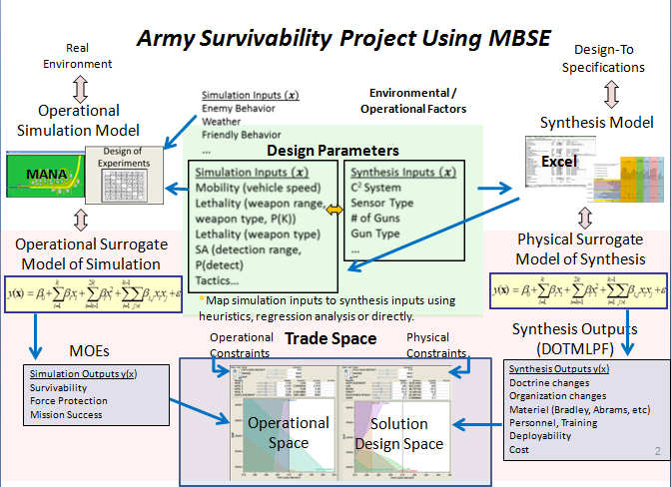

Figure 1 Army survivability project using MBSE process (from Professor Gene Paulo)

Specifically, the operational models were leveraged from existing projects, and the systems portion or design-to specifications element, was the focus of this process. However, this was an integrated effort and therefore, the operational assessment results drove the identification of the design parameters to evaluate, the secondary effects created by these changes and the overall operational impact to the system of system. The trade space tool seen at the bottom of the graphic is the physical implementation of the process developed. That “dashboard” represents the graphical user interface that a user would operate to quickly generate the results of a given scenario and desired outcomes. However, that specific implementation of the tool is recommended as follow-on work. The focus of this project was the process and relationships to enable the identification of that tradespace.

The foundation for the MBSE process lies in the SoS SE Elements found in the “Systems Engineering Guide for System of Systems” developed by the Department of Defense. (Systems Engineering Guide for Systems of Systems 2008) The DoD process as seen in Figure 2 revolves around “three of the core elements…critical to SoS SE: translating capability objectives, understanding systems and relationships, and monitoring and assessing changes.” (Systems Engineering Guide for Systems of Systems 2008, 29)

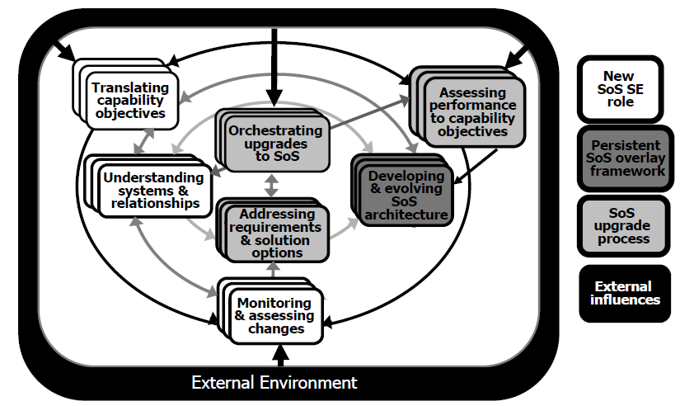

Figure 2 SoS SE elements and relationships (from (Systems Engineering Guide for Systems of Systems, 2008, p. 30)

The process developed for this effort, while based on the DoD model provides for a richer environment specific to the problem at hand. It focuses on the three core elements identified in the DoD model though the operational analysis, system architecture and relationship matrices and the alternative configuration implementation. However, this effort was focused on the modeling of a given scenario to identify the survivability impacts. Given that, the principles laid out in the SoS SE Guide were adhered to through the incorporation of the three core elements, but the specific interconnections and element steps were modified to meet the needs of this given objective. The elements specific to the upgrade process were not part of the scope, as this effort is the initiation of a modeling effort for analyzing a system of systems not implementing changes. Outside of those elements, the SoS SE principles drove the process laid out below.

The MBSE process shown in Figure 3 is a global view of the process that was used in developing the models and data. The five elements of the process are:

- Operational analysis to define the concept of operations and the required capabilities

- Developing the system functional architecture including interdependencies and relationships

- Systems analysis to determine critical functions to the required capabilities

- Developing a model and modeling toolset to analyze the system capabilities

- Execution of the model defining the baseline and the most appropriate changes to stress the baseline.

Each of these steps is further defined in the following sections.

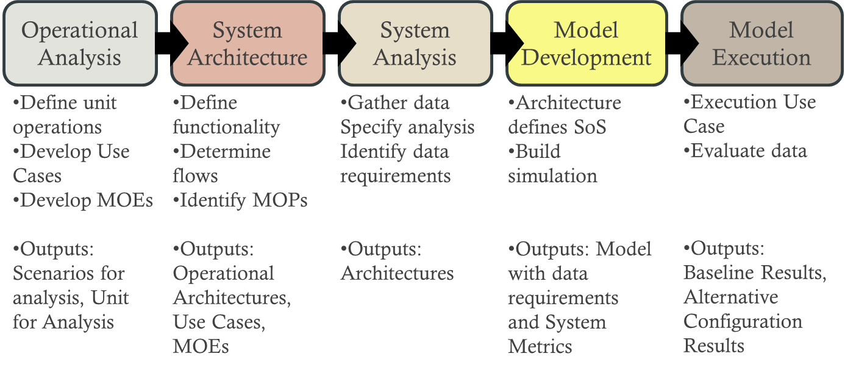

Figure 3 MBSE process for ground systems survivability robustness

# III. Operational Analysis

The Operational Analysis of phase 1 was founded in the operational viewpoint of the mission scenarios. This also played a role in the requirements identification, along with the stakeholder values, as it was focused on the identification of a specific mission to be evaluated from the operational perspective of overall survivability of a unit. Intrinsic to this phase was the selection of the mission scenario which acted as the basis to achieve the capstone requirements.

A key element in the operational analysis was the discovery of previous work at the Naval Postgraduate School (NPS) by Major Tobias Treml, FRG Army. Major Treml is an operations research student at NPS working toward his Masters. Treml’s work on developing an analytical underpinning for selecting specifications of future combat vehicles provided the basis for the analytical models on which this paper is based.

Treml developed an operational scenario within a tool called Map Aware Non-Uniform Automata (MANA). MANA is "an agent-based model developed by the Operations Analysis group at Defence Technology Agency in New Zealand.” (McIntosh, et al. 2007) This tool is agent – based and therefore “allows scenarios to be run relatively fast, over many excursions in order to discover unique situations or tactics where friendly forces can achieve dominance over an enemy.” [NEED CITATION] “Another key feature of agent-based models is that, although the one-to-one interaction between various agents and their environment may be quite simple, the combined effect of many agents interacting can lead to complicated group dynamics and emergent behaviour.” [NEED CITATION]

One of the fundamental elements of Phase 1 of the process is identification of the following information as laid out in the U.S. Army METT-TC (ADRP 3-0 Unified Land Operations 2012):

* Mission Variables (METT-TC)
* Mission shall define the tasks and purpose required of the identified unit
* Enemy shall define the capabilities, doctrine, and threat from opposing forces
* Terrain shall define the climate, environment, routes, obstacles, and fields of fire
* Troops shall define size, unit, capabilities, support, and status of friendly forces
* Time available
* Civil considerations

Completing a METT-TC provides the basic information necessary to complete specific use cases and architectures. Following this process, different missions can be developed, use cases created, architectures built, models executed, analysis completed, and the scenarios evaluated in an entirely repeatable fashion.

In conjunction with the defined mission variables, the entities (unit, vehicles, etc.) relevant to the operational scenario were identified utilizing invaluable input from the stakeholders. Within the context of this effort, combat vehicles were defined as the primary unit and attached or supporting vehicles and infantry. These supporting vehicles consisted of helicopters and unmanned air vehicles, which will be discussed further and evaluated as part of unit definition.

Next, an analysis of individual unit capabilities was developed to provide direction with respect to mobility, lethality, survivability and situational awareness. This was done by identifying initial system characteristics and capabilities of each platform. Additionally, the tactics and techniques for the unit was identified to create a decision based simulation that would emulate a real scenario. These baseline system characteristics were derived from the platform original equipment manufacturer (OEM) data sheets. The tactical decision process was developed using subject matter experts (SME) from former military personnel, initially developed by Treml. (Treml n.d.) This methodology defined the overall baseline, resulting in traceability to the requirements analysis.

Finally, utilizing the input from stakeholders and the prioritized capability requirements from the developed scenario and unit, appropriate Measures of Effectiveness (MOE) were determined. The four MOEs for assessment were blue force vehicle kills, blue force kills, Force Exchange Ratio and mission success. These MOEs drove the technical performance measures (TPM) that were used to identify the critical system functions and configuration changes.

## A. Stakeholders

### 1. Stakeholder Identification

This thesis has laid out a process that is multifaceted and spans many areas of the system development process. Therefore, there are multiple stakeholders interested in the different capabilities offered by the tools and process. The user, Science and Technology (S&T) and Acquisition communities all have an interest in the capabilities this process can provide. Table 1 depicts the major stakeholders that were identified and leveraged for guidance and requirements development.

|  |  |  |
| --- | --- | --- |
| **Project Role** | **Name** | **Expectation** |
| SPONSOR | | |
| RDECOM Sponsor | Mr. Dale Ormond, Director RDECOM | Applicable product, demonstration of systems engineering and model based systems engineering techniques to address difficult problems |
| RDECOM Representative | Ryan McCullough, HQ RDECOM | Applicable product |
| USERS | | |
| MCoE Representative | Ted Macuiba, | Applicable product to provide analytical underpinnings to capability decisions for survivability trade-space alternatives |
| PEO CS&CSS Representative | Bobbe Desmond, APEO SEI | Applicable product to provide insight to current systems and potential implications of capability improvements |
| PEO GCS Representative | Tony Desmond, APEO SEI | Applicable product to provide insight to current systems and potential implications of capability improvements |

Table 1 Stakeholders and users

In order to fully understand the needs of these stakeholders and the desired requirements, both primary and secondary research was performed. Initially stakeholder documentation was gathered, reviewed and parsed for applicable information regarding survivability definitions and current shortfalls. That information was used as the basis for the stakeholder interviews to gather more relevant information and clarify any questions that arose during the primary research portion. These interviews were held individually with the MCoE, the PEOs and the RDECOM community. This afforded each stakeholder the opportunity to voice their needs and requirements, without conflicting opinions sidelining the interview.

### 2. Stakeholder Analysis

The user community, specifically the Maneuver Center of Excellence (MCoE), is the main stakeholder for this project and is interested in an analytical process and methodology that tangibly measures the overall survivability of a system of systems, looking beyond the single vehicle enhancements to understand the implications to the overall unit. This creates a lack of understanding of what the improvements or “upgrades” to a single system mean in the overall scheme of the mission. This framework provides some analytical underpinnings to the assessments done to evaluate capability improvements for future systems. For example, the user is interested in what the improvements to survivability of the entire unit are if a specific aspect of a single system capability is modified.

Specifically, the stakeholder wanted to determine how to improve survivability without relying as heavily on armor as the current force does. Therefore, it was necessary to determine what the other factors that influence survivability were and what physical systems could be implemented besides armor. This process identifies the overall improvement to survivability in terms of FER, blue force kills, mission success and vehicle kills, taking into account not only the improvement to the given system, but the ramifications to other elements of the SoS. This will give the stakeholder a more justifiable explanation for capability decisions which account for design trade space implications.

The S&T community wants to know the direction that the future systems are moving. It is in the interest of the S&T community to be able to invest in areas of research to help the user community to achieve the capability improvements they are trying to implement. The first portion of this process will help the user define what capabilities will drive the greatest improvement in unit survivability. Next, identifying what materiel changes are required to make those capabilities a reality will fall onto the technology community. This will provide investment insight to what systems are going to provide the greatest return on investment (ROI) and what the secondary implications may be in terms of the trade space and design. Therefore, the RDECOM community is a stakeholder in the outputs of this process and toolset.

The third stakeholder of interest is the Acquisition community, specifically the system of systems interactions and the impacts of the desired capabilities on those existing systems. This stakeholder is key because it is necessary to have the acquisition community buy-in in order to employ system upgrades.

After meeting with all the stakeholders and studying the background information, a list of the top eight stakeholder values were assembled as seen in Figure 4.

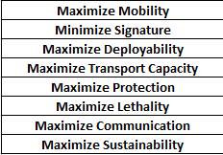

Figure 4 Stakeholder values

## B. Capability needs statement

The Maneuver Center of Excellence has a need to better understand the trade space available across key system and system-of-systems attributes that will provide an operationally effective, survivable and affordable capability to execute a wide variety of missions successfully.

## C. Top level system functions and Requirements

The system of interest is a system of systems, specifically a combined arms maneuver company with air support. The system operational requirements and functions are the focus of the research, as opposed to the system maintenance and support requirements and functions.

“A *function* refers to a specific or discrete action (or series of actions) that is necessary to achieve a given objective: that is, an operation the system must perform…” (Blanchard and Fabrycky 2011)

At this point it is beneficial to examine U.S. Army doctrine to note the operations that are used in land based campaigns as described in Army Doctrine Reference Publication, No. 3-0, Unified Land Operations.

To execute combined arms operations, commanders conceptualize capabilities in terms of combat power. Combat power has eight elements: leadership, information, mission command, movement and maneuver, intelligence, fires, sustainment, and protection. The Army collectively describes the last six elements as the warfighting functions. Commanders apply combat power through the warfighting functions using leadership and information.

(ADRP 3-0 Unified Land Operations 2012)

The approach involves adjusting design levels, or factors for four of the six warfighting functions (as achieved in system element performance adjustments), movement and maneuver, intelligence, fires and protection. The end state desired for the mission is acquiring and holding a defended objective which will be described in the next section. Some of the movement and maneuver tasks associated with achieving the goal are move, maneuver, employ direct fires, occupy an area, and conduct mobility and counter-mobility operations. The intelligence warfighting function tasks involved include 1)support situational understanding, 2) provide intelligence support to targeting and information capabilities, and 3) collect information. All of the fires warfighting functional tasks are called upon in the scenario to be studied; deliver fires, integrate all forms of Army fires, and conduct targeting. Two tasks from the protection warfighting function studied by the team were 1) conduct survivability operations and 2) coordinate air defense.

The combined arms maneuver system, with the warfighting functions and their associated tasks providing the context, has the following system level functions and requirements:

* defeat red ground forces,
* seize and occupy Objective 1 within 14 hours,
* minimize blue platform loss during conduct of mission (less is better, (O) = 0).

These achieve the desired end state of the scenario to be described, with a focus on survivability for the student team in support of the goals of the project stakeholders.

## D. Operational Concept and Scenario

Development of an operational concept and scenario was a critical component in developing the model. The basic concept of operations is contained in the TRADOC Analysis Center’s (TRAC) Multilevel Scenario 2 (MLS2). This scenario provides the strategic and tactical platforms, general command structures, and operational objectives with which to work. Additionally, the scenario outlines the forces available. Exploration of the activity surrounding this scenario led to Major Tobias Treml’s (FRG Army) unpublished operations research thesis *"*Alternative approach for the development of future Ground Combat System specification*"* and the supporting simulation model as a basis for the model development in this paper.

There were several key reasons for the utilization of Major Treml’s completed model. The simulation offered a far richer environment than could be create within the given time and skill set and provided very solid technical support as modifications were made to model.Additionally, the Treml model already incorporated several key model elements including both the terrain type and the force disposition (reinforced mechanized company with air support).

### 1. Baseline Mission Scenario

The baseline scenario for the MANA simulation has been provided by Treml. The scenario is generally a mechanized infantry aggressor against light infantry defenders supported by heavy mortar and heavy armor. The defenders are dug in and have emplaced IEDs and minefields to slow the aggressors and allow engagement. Here is the scenario, as described by Treml:

Blue Force, the aggressor, is a balanced company team (1 mechanized platoon, 1 tank platoon) of a Combined Arms Battalion (CAB) which attacks along a major highway 30 km south to take Objective 1 as prerequisite for the future attack by the Battalion against Objective HAWK which is outside the model space.

The company’s attack is the Battalion’s major effort and has priority over indirect fire support and is the main focus of the Battalion UAV reconnaissance effort.   Two medium attack helicopters will provide close air support and additional reconnaissance capabilities.

The Battalion Commander's intent for the company team is to maintain as much offensive momentum as possible to keep the enemy off balance but also to destroy detected enemy in the area of operations. After reaching Objective 1 the company team will secure the objective until follow-on forces attack over their own positions to Objective HAWK.

(Treml n.d.)

### 2. Initial Order of Battle

The initial order of battle in the simulation is shown in Figure 5. Blue Force is a task organized force consisting of four armored infantry fighting vehicles (IFV) with seven mounted infantry, four main battle tanks (MBT), one Battalion tasked 155mm howitzer, one Battalion tasked light unmanned aerial vehicle (UAV), and supported by two medium attack helicopters (MAH).

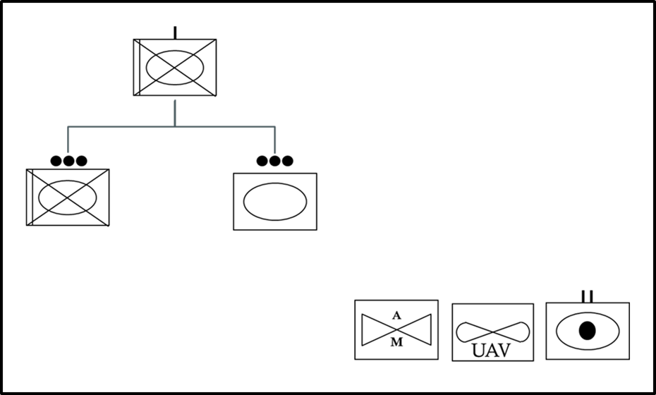

Figure 5 Initial order of battle

### 3. Initial Force Disposition

The OV-1 (Figure 6) shows the relative initial disposition of Blue force. The Blue force line of attack is shown as the blue arrow running from North to South; 2-way voice and data communication linkages from Blue force elements to HQ (yellow bolts) and Blue - Red tactical engagements (red lines). Objective 1 for Blue force is at the southern extreme of the battle area.

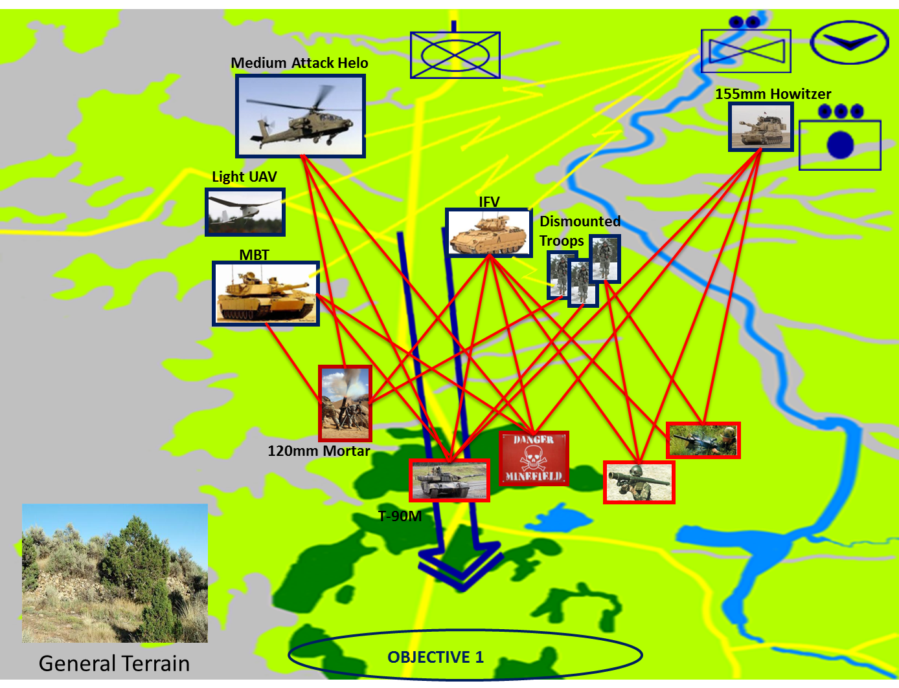

Figure 6 OV-1 Initial force disposition (After Treml, forthcoming)

### 4. Terrain and Red Force Composition and Disposition

The topography as defined by the TRAC MLS2 Scenario is a hilly/rugged area in a temperate climate with a mix of field and forest. This terrain, while playing to the mechanized infantry in many respects, also supports light infantry defenders with advanced weapons such as MANPADS, heavy mortars, and heavy armor support.

The terrain, as modeled within MANA, is a 30 kilometers wide and 40 kilometers deep. It is challenging, with cover for infantry as well as wide-open areas conducive to employment of long range weapons. The blend of various terrains provides for high speed movement for combat vehicles, as well as cover and possibilities for fighting positions. It provides mechanized forces the ability to move at high speed from north to south from generally open fields and rolling terrain to forests in the south. The southern extent of the operation area is modeled as dense vegetation with a high concealment factor and a medium cover factor. This terrain restricts sensor detection rates for agents and because of narrow canyons; vehicles have only limited access. This terrain provides excellent cover and concealment for defenders. The southern reaches are utilized by the Red forces to increase their effective combat strength.

The Red Force defensive positions are shown in Figure 7. Red Forces using surprise attack the Blue Forces from fortified concealed positions at close range. Their objective is to inflict as many casualties as possible on the Blue Force and stop or slow the Blue Force attack speed. (Treml)

A detachment of Red infantry (Infantry Group 1) has the advantage of emplaced IEDs to fortify northern position during the initial phase of the defense. When the Blue Force reaches the southernmost minefield, Red infantry (Infantry Group 2) will attack with 60-mm mortars, Milan anti-tank missiles, and indirect fire support from the 120-mm mortar section. While the infantry and mortar have the Blue Force pinned, the T90-M tank platoon will move forward and counterattack to destroy Blue Forces. A SA-18 Surface-to-Air Missile (SAM) team will provide single layer air defense.

Infantry Group 3 will be dug in at the southernmost point along the corridor of the Blue advance. They will intercept and engage any surviving Blue Force elements that break through the ambush position with light arms. Red company headquarters (HQ) will coordinate fire requests and provide battlefield information.

All forces will fight out of prepared defensive positions and will use the advantage of surprise. The intention is to inflict as many casualties as possible and defend successfully against Blue Forces. We follow Treml’s storyline in developing these scenarios.

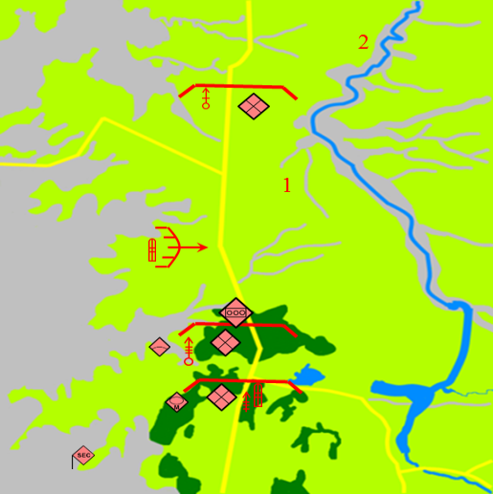

Figure 7 Red force defensive positions (From Treml, forthcoming)

Red Force equipment, capabilities and disposition generally follow the U.S. Army OPFOR Guide (Department of the Army Headquarters, FM 7—100.4 OPFOR *Opposing Force Organization Guide* 2007, XX).

## E. Measures of Effectiveness and Measures of suitability

A Measure of Effectiveness is, “a measure used to quantify the performance of a system, product or process in terms that describe a measure to what degree the real objective is achieved” (International Council on Systems Engineering, 2011, XX). Noting that the model and simulations are representations of the system of interest combined arms maneuver company with air support, the following have been established as Measures of Effectiveness;

1) Mission Completion/Success, which is defined as at least one main battle tank reaching objective 1 in (O) 100% of the simulation trial runs,

2) Number of Vehicles dead lined (rendered non-mission capable) as a Less is Better measure with (O) = 0 in 100% of the simulation trial runs,

3) Elapsed time to complete successful mission with (T) = 14 hours or less,

4) Force Exchange Ratio (FER) defined as (Blue losses/Total Blue)/(Red losses/Total Red) which is a Less is Better measure.

Vehicle survivability is a point of emphasis but the FER must be kept in mind as the baseline scenario for the combined arms company has only four blue infantry sections. Furthermore, the basic assumption is made that a platform’s crew does not survive when their vehicle is dead-lined during a simulation run.

The system Measures of Suitability/Performance (MOS/MOP) decompose (or support) the overall System Measures of Effectiveness. The model and simulation program chosen provides a variety of outputs that permit deeper examination of system design parameter choice effects and comparing performance between tested (simulated) system configurations. The first and second MOPs are related to MOEs # 1 and # 2: they are average number of main battle tanks operational at the end of the simulation, and average number of infantry fighting vehicles operational at the end of the simulation. MOP # 3 is the average number of model steps at run completion. The final MOP is related to the last MOE and is the ratio of dismount Blue Forces lost to the crew blue forces lost. This can give insight to the balance of the effects between ground combat system design parameters and indirect fire factors such as air and artillery support.

# IV. Systems Architecture

Phase 2 of the process required the development of a system of systems (SoS) architecture. A system of systems is viewed within the Office of the Secretary of Defense (OSD) as a “set or arrangement of systems that results when independent and useful systems are integrated into a larger system that delivers unique capabilities” (Office of the Deputy Under Secretary of Defense for Acquisition and Technology 2008). With the vast number of definitions of system of systems and the scope to identify all the integration elements, the choices made to limit the scope to the interdependencies and relationships that are directly impacted by the identified parameters. Therefore, secondary and tertiary effects of the interdependencies such as fuel economy, reliability or sustainment were not investigated. Process as defined here, however, includes as many of those elements as are identified. This broader scope of functions is included in the process to facilitate follow on work which could incorporate those factors.

During Phase 2, the System Architecture Phase, appropriate system functionality was identified and mapped to the stakeholders values. The system functions were then linked directly back to the operational scenario and unit being studied. The functional architecture is based upon an architecture developed by the Tank Automotive Research Development and Engineering Center (TARDEC) Systems Engineering Group (SEG) and being leveraged by current ground system program managers [NEED CITATION]. The original function set spanned 178 system functions. Many of the elements however were deemed to be outside the scope of this project. In order to scope down the functions, we list only the functions critical to the four main capabilities of interest, i.e., 1) mobility, 2) lethality, 3) situational awareness and 4) protection.

The level of fidelity for analysis was then determined and functions that were at too low of a level were eliminated. One of the functions, for example, that was deemed to be relevant was “Manage Signatures.” However, specific signatures such as thermal, infrared and visual were removed as being too low to be relevant in this study. This effort narrowed the list to 74 functions deemed to be relevant to the question at hand.

The final step in pairing down the list was two-fold. First, the specific areas of interest that have the greatest impact and differentiation on the combat system were identified by leveraging a report developed by the Program Manager (PM) Ground Combat Vehicle (GCV). PM-GCV developed the Whole Systems Trades Analysis Toolset (WSTAT). WSTAT is a “decision support tool that integrates otherwise separate subsystem models into a holistic system view mapping critical design choices to consequences relevant to stakeholders” (Davis 2012, XX). This report provided a summary of system functions and specifically those that provided the most differentiation in performance between solution options.

Next, the fidelity of the tool being used, MANA, was considered to identify which functions could be modeled and which ones were too low level. Once again those elements were parsed from the parent list to leave the final set of 20 functions depicted in Figure X. This figures demosnstrates the mapping of the functions back to the original stakeholder values that were identified.

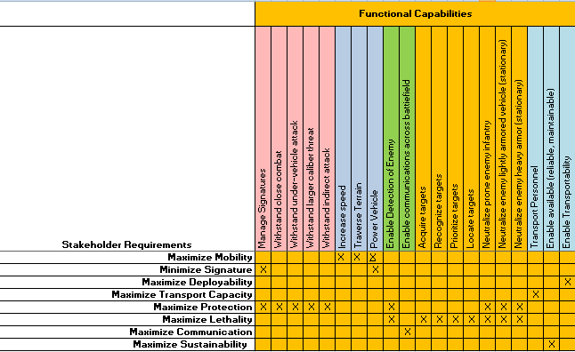

Stakeholder values mapped to functional capabilities (WSTAT Report)

The final 20 functions were used to develop the functional hierarchy, identify the function to function relationships, the function to physical relationships and the physical hierarchy. “[I]n an SoS, it is important to identify the critical set of systems that affect the SoS capability objectives and understand their interrelationships.” (Office of the Deputy Under Secretary of Defense for Acquisition and Technology 2008, XX). The function to function relationships provided insight to identify the dependencies between given system function that need to be managed and considered when working to achieve an overall capability. The dependencies were created with the help of SMEs from the given system area, as well as those with operational experience. Figure X depicts those relationships.

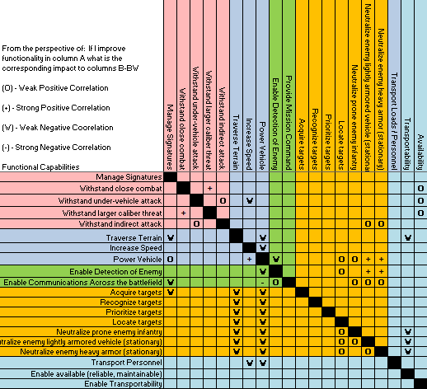

Function to function relationship matrix [from NEED CITATION]

Given the prospect of the functionality on the left being improved, the relationship to the corresponding functionality was identified as either weak or strong and positive or negative. This set the basis to identify the dependencies for the secondary and teriatry effects that an improvement or alteration would have on the overall SoS. Although these initial dependencies have been identified, it is necessary that the specific equations for each of these correlations be deteremined. That is recommended follow-on work.

Once the logical architecture had been laid out, the team was able to identify the key physical components of the SoS. The physical hierarchy was developed from a SoS perspective, the team leveraged the required capabilities, system functions and mission scenario to derive the top level components. Once the hierarchy was in place, a relationship matrix was created. As shown in Figure X, the matrix identified which components were utilized to satisfy the given function. This allowed the team to analyze which components had the greatest breadth of impact on the functions. Additionally, it allowed the team to prioritize the components for potential materiel changes, based upon functional impacts.

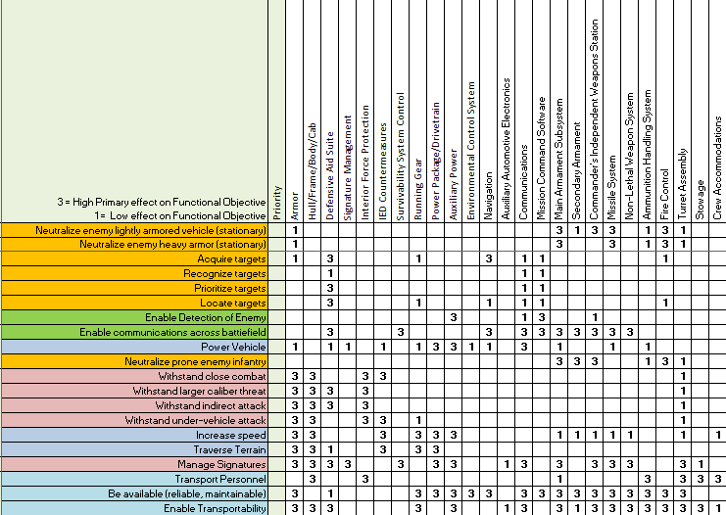

Function to physical relationship matrix [from NEED CITATION]

By implementing this process, the team was able to look at a specific design aspect within a given system or system of systems and implement a change to see how the outcome rolls up to impact the overall survivability MOEs of the unit.

## A. Functional decomposition

## B. Physical decomposition

# V. Systems Analysis

Once the functional and physical hierarchies were developed and correlated, the measures of success and the desired outcomes of the model, identified by the stakeholders, were used to derive the Technical Performance Measures (TPMs). The model was focused on survivability in terms of lethality, situational awareness, mobility and protection. Therefore, the metrics derived from the MOSs were in those four categories, along with identifying sustainment measures that are impacted by the functions. These metrics are depicted in Figure X as part of the correlation matrix.

The functions were evaluated against the TPMs by assessing the impact that each metric has on the given function. This evaluation was completed by utilizing input from former operators and SME judgment. The former operators consisted of a member of Navy and a Marine whom were able to provide insight from an operations view. Additionally, SMEs in networks, survivability and mobility from TARDEC, ARDEC and Aberdeen provided input to the correlations identified in the matrix.

The matrix in Figure X is part of an analysis process used in the determination of materiel improvements and alternative configurations for achieving higher survivability outcomes. This process will be discussed in greater detail in the model development and model execution components of the paper.

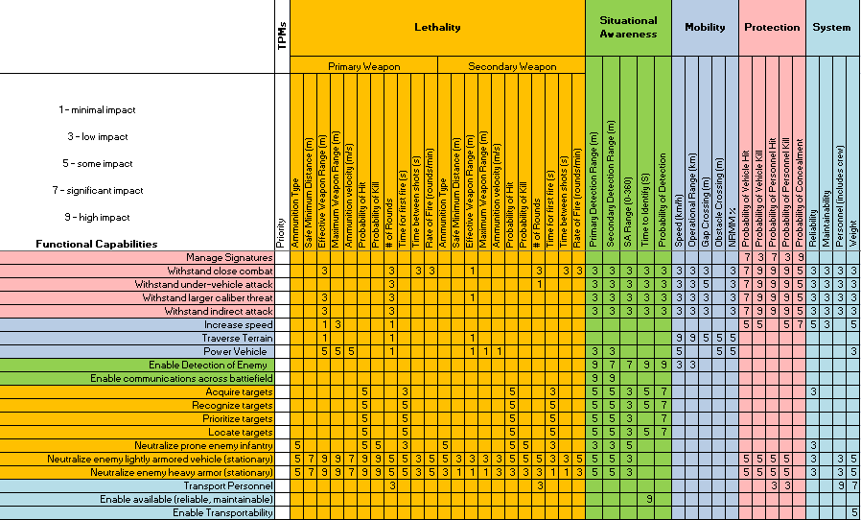

The identification of the TPMs was the first step in executing the Nearly Orthogonal Latin Hyper cubes evaluation. “Latin hypercube designs are geared for simultaneous study of p input factors. Whereas standard factorial designs limit each input factor to a small number of distinct values, Latin hypercube designs use different settings of each factor on each experimental run, with the settings spread out uniformly along each factor axis. Thus Latin hypercube designs achieve a very ‘uniform’ coverage of each individual factor.” (<http://www.personal.psu.edu/users/j/x/jxz203/lin/Lin_pub/2006_Biometrika.pdf>) Therefore, the NOLH approach was utilized as opposed to a standard design of experiments approach, due to the large number of variables being examined. JMP was utilized to generate the NOLH for evaluation as well as evaluate the results. A total of 11 factors were evaluated across the system of systems, varying different factors on different platforms around the baseline. This provided insight into the operational outcome of a given set of varied factors in terms of the four responses; Blue Forces killed, vehicles killed, FER and mission success. This data was then input back into JMP and regression analysis was performed to identify which of the 11 factors had the greatest impact on the outcomes of survivability.

Where Phases One and Two defined the decisions to be made in the development of the methodology and example architectures, Phase Three results provided insight into the variability in and range of operational effectiveness achievable. The results of this analysis helped determine the different instantiated solutions that satisfy the functional and performance requirements to varying degrees with different trade off considerations which were substituted into and out of the models to stress the scenario’s baseline architecture. Once those areas were identified, the team worked to gather data and identified specific alternate configurations, both materiel and non-materiel, which further exercised those elements. The specific secondary effects and tradeoffs, based upon configurations, were determined though the model-build and execution phases of the process.

# VI. Model Development

During this phase of the process, a culmination of the information and data determined from the initial phases was used to structure and build the models. The models utilized the capabilities, systems, functions, relationships, and variables of both enemy and friendly forces. The model analyzed a single company against enemy forces in the terrain defined by the operational scenario. Specifically, building the model was the integration of the individual elements previously identified. The tools themselves were not physically integrated, but the data from each of them was tied together to create a process flow from requirements to functions to systems; next, the secondary effects and how those were to be implemented in the operational analysis were identified. Figure X depicts the high level steps carried out through the modeling process as a subset of the overarching process shown in figure 2 and the tools which were used to implement that process. The development of the “Perform Analysis” step will be detailed explicitly in this section because the first two steps have been discussed at length previously.

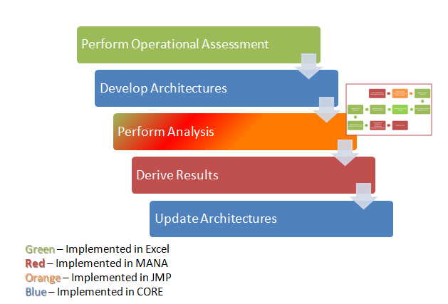

Top level integrated modeling process

The required data had been developed and recorded and the necessary matrices had been developed in the initial phases of the process. The next step was to integrate all the pieces into a single process flow for a complete set of results. Model integration consisted of bringing together two distinct elements of analysis. The first step was the system analysis being done through the process outlined in Figure X. This was done through the generation of the NOLH, execution of the NOLH in MANA, assessment of the MANA outputs in Excel, analyzing the results in MANA and determining the top level metrics to drive the configurations to improve the operational survivability. This has been laid out in the preceding sections, proving the necessary results.

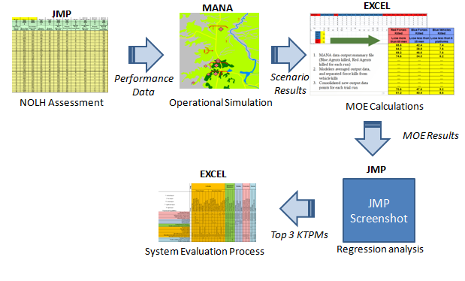

NOLH modeling process

The second element was the system evaluation model. This model utilized the outputs from the NOLH modeling to determine the best materiel changes to implement in the overall process. This was carried out through the process seen in Figure X. The matrices were built with the desire to identify secondary effects as the primary goal of the system evaluation model. It was determined that the implementation of a new technology or capability may improve the overall survivability, but the unforeseen integration concerns and secondary effects could prove to be detrimental to the overall unit. Therefore, a major concern of the process was the relationships among the elements, such as function to metric, as well as between the elements, such as the ‘function to metric’ matrix to the ‘function to physical’ matrix. Therefore, once the system capabilities had been utilized to derive the required system functions and the system functions had been utilized to derive the physical systems, all the correlations among the elements could be evaluated. The execution of this process and model will be expanded upon in the Model Execution phase.

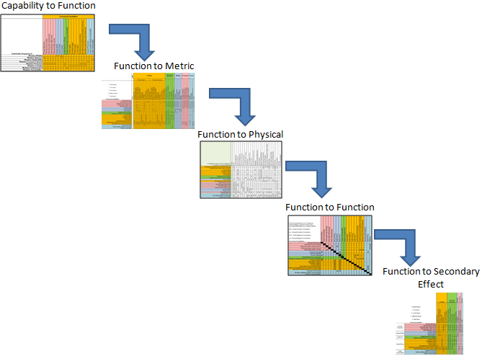

System evaluation model

## A. Variables and Factors

### 1. Variables of Interest

The factors detailed previously were chosen because they fulfill the functions critical to the four main capabilities of interest; mobility, lethality, situational awareness, and protection. Varying them allowed for the determination as to how they affected the survivability of the system and which one(s) had the greatest impact on the system. Further factors were initially considered, but were scaled down in an effort to limit the scope to the interdependencies and relationships that are directly impacted by the parameters previously identified. As stated earlier, secondary and tertiary effects of the interdependencies such as fuel economy, reliability, or sustainment were not investigated.

### 2. Inputs and Outputs

When building the MANA models, there were a number of inputs that needed to be taken into consideration in order to ensure fidelity of the models. Listed below are the main areas of concern that needed to be addressed:

* Agents (both platforms and infantry)
* Agent Attributes
* Operational Environment (terrain and elevation).

Modifying these areas allowed for the customization of different operational scenarios which helped in the determination of both a factors’ significance and the significance of individual agents. Initial configurations predominately dealt with modifying the agent attributes of the baseline scenario provided by Major Treml which yielded data that was used to determine factor significance. Later configurations modified the agents themselves, which yielded data that was used to determine the significance of individual squad components.

In order to determine the effectiveness of a scenario configuration, there were a number of items outputted from MANA and used, they include:

* Blue Force Vehicle Kills
* Blue Force Kills
* Force Exchange Ratio
* Mission Success.

As stated in the MOE section, lower values for Items 1-3 and a larger value for Item 4 are considered ideal. The number of Blue Force Vehicle Kills and Blue Force Kills were each determined by averaging the values from the multiple simulation runs for each configuration and adding them together for an overall value. The Force Exchange Ratio was calculated in a similar manner in that both the Blue and Red Force kills were calculated and then plugged into the equation detailed in the MOE section for an overall value. Finally, mission success was determined by averaging the values from the multiple runs for each configuration as well. The data was manipulated in this manner in order to get it ready for a regression analysis which will be discussed more in a later section.

# VII. Model Execution

Finally, Phase Five of this initial effort will be Model Execution. This phase includes the actual running of the model, identification of a baseline and baseline results, and integrating system improvements and use case variations to evaluate the effects on the overall survivability of the unit. This will allow the team to analyze what are the key areas of design and which system qualities create the greatest impact on the overall survivability of the unit, thereby providing the most likely trade space to work within.

A model will be developed with a simulation program to analyze the mission survivability based upon the provided data. This will allow for a baseline to be set for each of the scenarios, utilizing a common unit, and then alternative configurations will be introduced to identify the overall impact to survivability, force protection, operational success and cost. This beta model will be utilized to deliver indications and trends, but not specific solutions or recommendations.

Finally, an analysis of alternatives will be completed to identify the current capabilities and tools that exist to implement this process for a more user friendly interface as well as to recommend the path forward for follow-on efforts.

## A. Analysis Tools

Several tools were used in both the analysis of the data produced by the models and in the design of experiments. The nearly orthogonal Latin hypercube (NOLH) methodology was applied to reduce the number of comparisons required in order to obtain results while still maintaining statistical integrity. (Hernandez 2008)

Statistical methodologies were applied to the data in order to discern patterns. Specifically, SAS Corporation’s JMP software package was utilized for the statistical analysis. According to the SAS corporate website, JMP is, “…desktop statistical discovery software from SAS built with scientists and engineers in mind” (SAS Institute Inc 2013). The JMP software was used extensively to assist in the interpretation of the large amounts of data obtained as a result of our model runs. The software's capabilities for exploratory data analysis, combined with similar capabilities for statistical modeling and predictive analytics, were used to achieve a better understanding of the data. Several statistical methodologies helped us identify the factors of greatest influence in our desired outcome. We used principle component analysis (a multivariate method), as well as categorical analysis, multivariate analysis of variance (Fit MANOVA), and the fit model platform.

Principal component analysis provided the focus on the most important factors, those most affecting the outcomes. The tool simultaneously considers “a small number of independent linear combinations (principal components) of a set of variables that capture as much of the variability in the original variables as possible” (SAS Institute Inc. 2013).

Back of the envelope (BoE) calculations were conducted using Microsoft’s Excel for tabulating experimental model results, recording and distributing design of experiment (DoE) data, and were also used for managing correlation matrices. Easily integrated with the primary statistical analysis tool, JMP, Excel provided a distribution and collection point for both DoE data and model results, allowing quick and easy tabulations of basic success and failure summaries. It also had the benefit of being readily accessible and provided no additional burden to the learning curve.

Map Aware Non-uniform Automata (MANA) is an agent-based simulation tool capable of carrying out complex experiments in compressed time. The Operations Analysis group at Defence Technology Agency in New Zealand developed it as a flexible platform for quickly and easily modeling complex behavior among autonomous agents (McIntosh, et al. 2007). This type of modeling is particularly well suited to capturing the behavior, interaction, and performance of military vehicles and warfighters in simulated combat. [NEED CITATION] Parameters for each agent, in this case, individual vehicle platforms and infantry, can be adjusted and the outcome measured for changes in effectiveness. For example, the maximum effective range for a primary weapon on a main battle tank (MBT) can be adjusted and the results recorded. This allowed us to make many such adjustments over multiple runs to determine the most critical parameters to squad success.

Agent-based modeling is a distinctly different approach to traditional centralized modeling (McIntosh, et al. 2007). Traditional modeling methodologies rely on a central engine which continually calculates and determines the behaviors, actions, and effects for every constituent model piece, simultaneously. [NEED CITATION] In agent-based modeling, the disposition and capabilities of individual model actors (automata) is determined in advance and the actions influenced by the disposition and enabled through the capabilities is calculated and carried out by each actor. [NEED CITATION] In this way, MANA very accurately represents the type of system of systems that we are modeling.

MANA allows multiple runs to be set up and data to be captured, providing the basis for our statistical analysis in JMP. The resultant comma separated value (CSV) files were imported into Microsoft Excel, cleaned up, and some additional calculations were performed (e.g., Force Exchange Ratio - FER). The cleaned up data was then

## B. Simulations

The Department of Defense (DoD) defines modeling and simulation (M&S) as the use of models, including emulators, prototypes, simulators, and stimulators, either statically or over time, to develop data as a basis for making managerial or technical decisions (*DOD 5000.59-M* 1998) (Defense 1998). These models help test war plans against adversaries, influence force structure decisions, determine what equipment to acquire, decide the best combination and use of weapons, and explore potential changes in doctrine or tactics (Cioppa 2003). The value of M&S is that it serves as an alternate approach to real world testing, which often involves costly hardware and other resources. As a system of systems is characterized by complex combinations and interdependencies of technologies, operations, tactics, and procedures, leveraging M&S techniques can ease the challenges of analysis across multidimensional trade spaces (Anderson 2003) ***

### 1. Approach

In order to best support the Maneuver Center of Excellence need, which is to improve the understanding of the system-of-systems trade space for survivability, it is important to utilize an modeling and simulation (M&S) approach that is suitable for the underlying problem. Across the METT-TC spectrum, military conflicts involve a vast array of attributes that are necessary to evaluate, and which would be required inputs of any quality model or simulation tool. Since some of these simulation inputs are unknowable, it makes sense to reason across a broad range of input variable levels (Bankes 1992). It may seem obvious, on the surface, that in order to analyze ground combat vehicle survivability, one must first understand the interrelationships of mobility, lethality, and protection, and further, how they support the goal of enhanced survivability. Unfortunately, this assumption is incorrect, and it is precisely the trade space of these functional elements that can be explored through M&S. The following sections describe the M&S approach, and the means by which simulations were prepared.

#### a. Agent-based simulations

There continues to be increasing interest from a broad range of disciplines in agent-based and artificial life simulations. This includes the Department of Defense – which uses simulations heavily in its decision making process (T. M. Cioppa 2004). In the contents of agent-based simulations, agents are understood to be software objects that perceive their environment through sensors and act on that environment (Weiss 1999). In short, an agent can sense their environment, communicate with other agents, build perceptions, make decisions, and take actions in an attempt to simultaneously satisfy multiple objectives (T. M. Cioppa 2004). For assessing a combined arms unit as a system of systems, an agent-based simulation allows for an accurate scenario configuration, to be assessed across many environments, for many equipment capabilities, and in accordance with several training and doctrinal procedures.

#### b. Map Aware Non-Uniform Automata (MANA)

Developed by New Zealand’s Defence Technology Agency (DTA), Map Aware Non-Uniform Automata (MANA) was designed for use as a scenario-exploring model, and is intended to address a broad range of problems. It is described as an agent-based distillation model, for use in military operations analysis studies, and is based on two key ideas: 1) that the behaviour of the entities within a combat model (both friend and foe) is a critical component of the analysis of the possible outcomes, and 2) that we are wasting our time with highly detailed physics-based models for determining force mixes and combat effectiveness (McIntosh et al. 2007). . For this effort, it is precisely the behaviors and interrelationships amongst a combined arms unit, as well as the interactions with enemy forces, that comprise the evaluation criteria for exploring the survivability trade space. Unlike most models, where a pre-determined series of events are constructed based on initial run conditions, the “non-linear nature of MANA ensures that, regardless of the modeller’s preconception, a startingly large number of outcomes are possible” (McIntosh et al. 2007). Additionally, because the agents do not always behave in a sensible, -perfect manner, the model provides an element of real-world behavior that is quite necessary.

#### c. Squad properties

Utilizing the CONOPS and scenario developed by Major Treml, the squads serving as the basis for the simulation and analysis were established. In MANA, a squad is defined as a group of agents, which can be of size between one and 1000. An agent is quite simply an individual infantry soldier or weapon platform (e.g., tank, aircraft, mortar, etc.), and all agents within a given squad are comprised of the same properties. “Properties, or rather parameters, within MANA can be divided into four types: personality weightings, move constraints, intrinsic capabilities, and options for adjusting movement constraints” (McIntosh, et al. 2007). It is the intrinsic capabilities (i.e., weapons, sensors, movement speed) that are the focus of the adjusted variables, and which helped to generate data points for the trade space analysis. Figure XX identifies the squad elements that comprise both the blue and red forces. The number reflected in the matrix represents the number of agents belonging to that particular squad, while the parenthetical reference indicates the number of troops assigned to each agent. For example, “Bradley(3)” indicates that there are three troops contained within the Bradley agent, and that there is one BIFV platform in the squad.

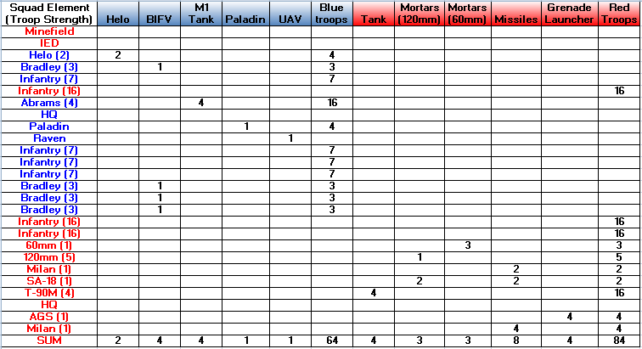

Figure XX – Force Configuration

Further, Figure XX displays the design factors that would define which intrinsic capabilities within MANA squad properties must be modified. Figure XX also identifies the baseline values for each factor, as represented in the Treml baseline, as well as the intended minimum and maximum performance values that would set the boundaries of our design space.

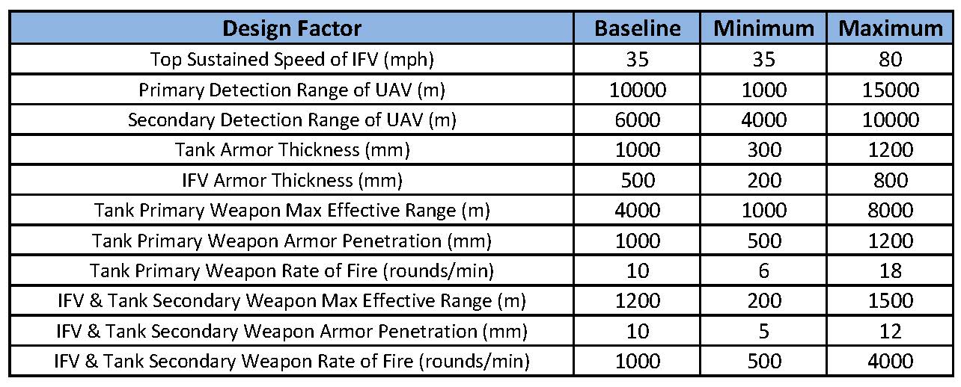

Figure XX – Design Factors and Thresholds

### 2. Process

The effectiveness of any model or simulation tool, and the validity of its results, lies in the feeder data, as well as the process in which it is utilized. For the 11 factors that were varied under the conditions of the Treml baseline, stakeholder input was solicited to ensure that 1) performance ranges of the individual factors were reasonable with respect to known values, and 2) ranges were adjusted slightly so as to protect classified information. Once the minimum and maximum values were assigned for each factor, it was necessary to develop a series of configurations to simulate the entire design space. Assuming for a moment, that only two values, the maximum and minimum, for each factor are considered for the design space, a full factorial design would require 211, or 2,048 different design configurations. Understanding that some of the design factors contain ranges on the order of thousands, the number of possible design configurations becomes extremely difficult to calculate, and unreasonable to simulate. Thus, it was advantageous to leverage a methodology that is capable of simulating a design space that provides a comprehensive representation of the complete configuration set.

#### a. Nearly Orthogonal Latin Hypercubes

When it becomes unfeasible, in terms of both time and resources, to test all possible configurations of a full factorial design, we turn to alternative methods as a means to help achieve similar results. In order to sample the entire design space and still retain completeness and validity of the sample design and its results, we can utilize Nearly Orthogonal Latin Hypercube (NOLH) sampling. A key property of these efficient, space-filling designs is their ability to explore many factors within a relatively modest number of design points (Hernandez 2008). Quite simply, NOLH sampling allows for a subset of the entire design space to be constructed such that it provides even distribution. As depicted in Figure XX, the NOLH approach trimmed the full design from thousands of configurations to a much more manageable 66. Note that only the first five and final five configurations are depicted, so as to maintain readability within this report. For the full sample design space, see Appendix X.

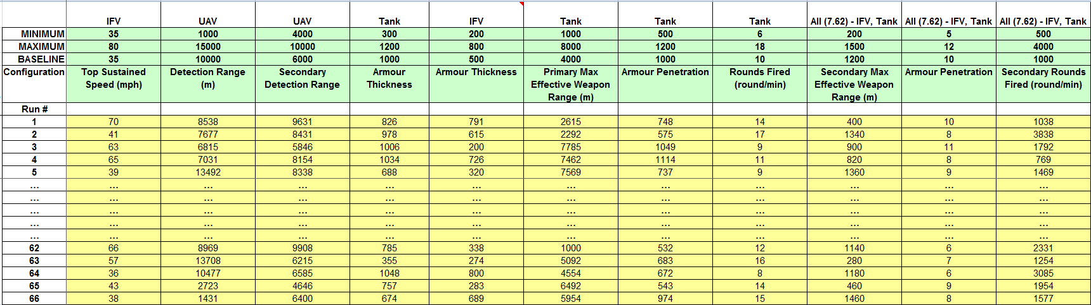

Figure XX – NOLH Design Space

#### b. Baseline model

As previously mentioned, the baseline model was leveraged from the constructed operational concept and scenario set forth by Major Treml. The model was loaded into MANA to establish the basis for parameter modifications, in preparation for the simulation runs. From Figure XX above, the parameters from the baseline scenario were modified in accordance with the configurations defined by the NOLH design. Each factor linked to an intrinsic capability in the MANA squad properties, and was modified as follows:

1. Top Sustained Speed (IFV) – This parameter defines the maximum sustainable ground speed of the IFV in miles per hour. The movement speed of all four IFV squads was modified in accordance with the configuration run.

2. Primary Detection Range (UAV) – This parameter defines the maximum detection range of vehicles for the UAV in meters. The baseline scenario assigns a series of detection ranges, each with a unique, corresponding probability of detection. For instances when the primary detection range of the defined configuration run exceeded the 10,000 m baseline value, the new detection range replaced 10,000 m as the maximum value, and assumed its probability of detection. For ranges less than the 10,000 m baseline maximum, the detection range was inserted in place of the next highest range, and all higher ranges omitted. Probabilities were then adjusted so that the maximum detection range meets the baseline probability to detect of 0.05.

3. Secondary Detection Range (UAV) – This parameter defines the maximum detection range of infantry soldiers for the UAV in meters. The baseline scenario assigns a series of detection ranges, each with a unique, corresponding probability of detection. For instances when the primary detection range of the defined configuration run exceeded the 6,000 m baseline value, the new detection range replaced 6,000 m as the maximum value, and assumed its probability of detection. For values less than the 6,000 m baseline maximum, the detection range was inserted in place of the next highest range, and all higher ranges omitted. Probabilities were then adjusted so that the maximum detection range meets the baseline probability to detect of 0.05.

4. Armor Thickness (Tank) – This parameter defines the armor thickness of the Tank in millimeters. The armor thickness of the tank squad was modified in accordance with the configuration run.

5. Armor Thickness (IFV) – This parameter defines the armor thickness of the IFV in millimeters. The armor thickness of all four IFV squads was modified in accordance with the configuration run.

6. Primary Max Effective Weapon Range (Tank) – This parameter defines the primary maximum effective weapon range of the Tank’s 120mm gun in meters. The baseline scenario assigns a series of weapon ranges, each with a unique, corresponding probability of hit. Due to the classified nature of this type of information, probability of hit data correlating to effective weapon ranges was unattainable. Thus, two assumptions had to be made: 1) At a weapon range of 0 meters, the probability of hitting a target is 100%. 2) “Effective” is defined as being 90% likely, and thus the maximum effective weapon range as defined by the configuration run would be assigned a 90% probability of hit. All other ranges associated with the baseline performance values were omitted.

7. Primary Weapon Armor Penetration (Tank) – This parameter defines the armor penetration capability of the Tank’s 120mm gun in millimeters. The armor penetration capability of the tank squad was modified in accordance with the configuration run.

8. Primary Weapon Rounds Fired (Tank) – This parameter defines the capability of the number of rounds fired by the Tank’s 120mm gun in rounds per second. The number of rounds fired by the tank squad was modified in accordance with the configuration run. It should be noted that while this design factor is represented in rounds fired per second, MANA captures this factor in terms of rounds fired per 100 seconds, and thus appropriate translation was required.

9. Secondary Max Effective Range (Tank/IFV) – This parameter defines the secondary maximum effective weapon range of the Tank and IFV’s 7.62mm gun in meters. The baseline scenario assigns a series of weapon ranges, each with a unique, corresponding probability of hit. Due to the classified nature of this type of information, probability of hit data correlating to effective weapon ranges was unattainable. Thus, two assumptions had to be made: 1) At a weapon range of 0 meters, the probability of hitting a target is 100%. 2) “Effective” is defined as being 90% likely, and thus the maximum effective weapon range as defined by the configuration run would be assigned a 90% probability of hit. All other ranges associated with the baseline performance values were omitted.

10. Secondary Weapon Armor Penetration (Tank/IFV) – This parameter defines the armor penetration capability of the Tank and IFV’s 7.62mm gun in millimeters. The armor penetration capability of the tank squad and all four IFV squads was modified in accordance with the configuration run.

11. Secondary Weapon Rounds Fired (Tank/IFV) – This parameter defines the capability of the number of rounds fired by the Tank and IFV’s 7.62mm gun in round per second. The number of rounds fired by the tank squad was modified in accordance with the configuration run. It should be noted that while this design factor is represented in rounds fired per second, MANA captures this factor in terms of rounds fired per 100 seconds, and thus appropriate translation was required.

#### c. Non-materiel change configurations

###### i. Unit composition

The design factors from Figure XX represent a series of performance characteristics across several weapons and weapon platforms, indicating variances in potential materiel solutions. However, there are other considerations across the DOTMLPF spectrum which can certainly contribute to improved survivability of ground combat vehicles. Doctrinal and/or organizational changes may result in different outcomes in battle, and so along with materiel considerations, these non-materiel possibilities must be considered as well. Figure XX represents the design space for various configurations of platforms within the unit. All platforms are outfitted with their baseline performance capabilities, although the number of platforms is randomized, to account for different organizational approaches.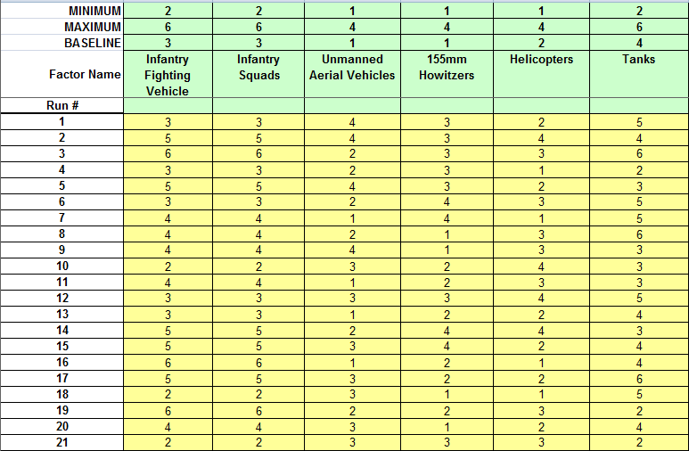 **FIGURE XX. Unit Composition Design Space**

The baseline scenario, as defined by Treml, was run 35 times for each design configuration, to explore the results of non-materiel changes to the unit. Each platform, and its role with respect to mission, is defined below.

* Infantry Fighting Vehicle (IFV) – The IFV is an armored vehicle that provides fire support to the battlefield, as well as serves as the carrier for Infantry dismounted troops. The number of IFVs in the unit is varied between two and six platforms.
* Infantry Squads – The infantry squads represent a set of seven infantrymen who are typically engaged in face-to-face combat. Each infantry squad belongs to an IFV, and these are varied between two and six squads in this unit.
* Unmanned Aerial Vehicle (UAV) – The UAV is a pilotless aircraft that provides reconnaissance, surveillance and remote sensing capabilities from an elevated distance. The UAV is an unarmed platform, and is varied between one and four platforms in this unit.
* 155mm Howitzer – The howitzer is a stationary artillery weapon, which provides fire support to the battlefield from a distance. The number of howitzers in this unit varies between one and four platforms.
* Helicopter – The attack helicopter (helos) provides aerial fire support to ground targets on the battlefield as well as supplemental detection capabilities. The number of helos in this unit varies between one and four platforms.
* Tank – The tank is the primary armored combat vehicle on the battlefield. It provides the unit with operational mobility, as well as tactical offensive and defensive capabilities. The number of tanks in the unit is varied between two and six platforms.

imported into JMP for further analysis.

## C. Design of Experiments Planning

#### a. Model Data References and Definitions

#### b. Factor Levels and Probability Distributions

#### c. Probability Model

#### d. Factorial Design

#### e. OMOE for Cost As Independent Variable

# VIII. Results

### 1. Regression Analysis and CAIV Results

### 2. Baseline Analysis

### 3. Alternative Configuration Analysis

# XI. Summary and Recommendations

## A. Challenges

The lack of higher power tools and assistance reiterates the necessity of the process as the foundation for this type of work. The process as stated can be followed using different tools to achieve a higher fidelity model. Process outlined in this thesis identifies the type of data and steps required to achieve an outcome, and it does not dictate tools to use.

## B. Follow-on Work

This study, though constrained by time, identified some very interesting areas for future investigation.

### 1. Dashboard

A nicely designed user interface that allows the end user to directly interact with the model would facilitate a higher level of interactive investigation, facilitating access to insight and understanding that currently require a working understanding of MANA. This would also facilitate access to the model by lay-persons or engineers working within a given specialization to realize in advance the effects on the system of systems to changes within their given subsystem.

### 2. Closer modeling of 2nd order effects

Further detailed development of models of the subsystems (e.g., propulsion, protection, and weapons systems on the vehicles) could provide valuable information about second order effects of changes to the vehicle configurations. For example, given the current model it is very difficult to say with any accuracy what the effects of a larger main gun are to lethality, mobility, survivability, and force protection.

### 3. Investigation of emerging technologies

There exist some very exciting emerging technologies that were beyond the scope of this initial investigation that potentially allow increased capability with significant reduction in undesirable second order effects. Included in these are high energy weapons, e-ink camouflage, and new ground combat systems.

### 4. Broadening of the trade space

The work that was done was very narrowly focused on ground combat in a Brigade Combat Team (BCT) such as an infantry fighting vehicle or a main battle tank. There is great potential in using the existing work to expand the scope, for example, to include air support, logistics, and joint operations.

## C. Recommendations

# Appendix A: Reference Models for Simulations

# Appendix B: Simulation Output Data

THIS PAGE INTENTIONALLY LEFT BLANK

# LIST OF REFERENCES

*ADRP 3-0 Unified Land Operations.* Washington DC: Headquarters, Department of the Army, 2012, 76.

Anderson, Dennis J. "Evaluating a Complex System of Systems Using State Modeling and Simulation." *National Defense Industrial Association Systems Engineering Conference.* Sand Diego, CA: Sandia National Laboratories, 2003. 31.

*Army Equipment Modernization Strategy.* Future Force Division (FDF), Washington DC: Department of the Army Office of the Deputy Chief of Staff, G-8 Future Force Division (FDF), 2013, 44.

Bankes, Steven C. *Exploratory modeling and the use of simulation for policy analysis.* Santa Monica, CA, 1992.

Blanchard, Benjamin, and Wolter Fabrycky. *Systems Engineering and Analysis.* 5th. Upper Saddle River, New Jersey: Prentice-Hall, 2011.

Cioppa, Thomas M. *Advanced experimental designs for military simulations.* Monterey, CA: US Army TRADOC Analysis Center, Naval Postgraduate School, 2003, 35.

Cioppa, Thomas M. "Military Applications of Agent-Based Simulations." *Winter Simulation Conference.* Washington, D.C.: Naval Postgraduate School Department of Operations Research, 2004. 171-180.

Davis, Scott J. *Q&A: Scott J. Davis.* August 2012. http://www.military-advanced-education.com/gct-home/427-gct-2012-volume-3-issue-4-august/5827-qaa-scott-davis.html.

Defense, Department of. "DOD 5000.59-M." *DoD Modeling and Simulation (M&S) Glossary.* Washington, D.C., January 1998.

Department of the Army Office of the Deputy Chief of Staff, G-8 Future Force Division (FDF). *Army Equipment Modernization Strategy.* Future Force Division (FDF), Washington DC: Department of the Army, 2013, 44.

Ewing, Dell, MacCalman, Whitney. *Capability portfolio analysis tool (CPAT) verification and validation report.* Monterey: Naval Postgraduate School, 2013.

*FM 3-21.31 The Stryker Brigade Combat Team.* Washington DC: US Army Infantry School, Department of the Army, 2003.

*FM 7– 100.4 OPFOR Opposing Force Organization Guide.* Washington DC: Headquarters Department of the Army, 2007.

Haulman, Dr. Daniel L. *NO CONTEST: AERIAL COMBAT IN THE 1990s.* Maxwell AFB, AL: U. S. Air Force Historical Research Agency, 2002.

Hernandez, Alejandro S. *Breaking barriers to design dimensions in nearly orthogonal Latin hypercubes.* dissertation, Monterey California: Naval Postgraduate School, 2008, 158.

International Council on Systems Engineering. "Systems Engineering Vision 2020." September 2007.

Kelly, Terrence K., Eric Landree, John E Peters, Randall Steeb, Louis R Moore, and Aaron Martin. *The U.S. Combat and Tactical Wheeled Vehicle Fleets.* National Defense Research Institute,, Arlington VA: RAND Corporation, 2011, 181.

Kempinski, Bernard, and Christopher Murphy. "Technical Challenges of the U.S. Army’s Ground Combat Vehicle Program." *Working Paper Series Congressional Budget Office* (Congressional Budget Office), November 2012: 64.

Mait, Joseph N., and Richard L Kugler. "Alternative Approaches to Army Transformation." *Defense Horizons*, July 2004: 9.

McIntosh, Gregory C., David P Galligan, Mark A Anderson, and Michael K Lauren. "Recent Developments in the MANA Agent-based Model." *Scythe - Workshop 13.* Singapore: International Data Farming Community, 2007. 38-39.

Molitoris, Heather, and Daniel Hicks. "System Engineering approach to assessing Integrated Survivability." Warren, MI: US Army RDECOM-TARDEC, August 2009.

Office of the Deputy Under Secretary of Defense for Acquisition and Technology, Systems and Software Engineering. *Office of the Deputy Under Secretary of Defense for Acquisition and Technology, Systems and Software Engineering. Systems Engineering Guide for Systems of Systems, Version 1.0.* Washington, DC: ODUSD(A&T)SSE, 2008.

Pederson, Robert B. *A Study of Combined Arms Warfare by Alexander the Great.* Thesis, Fort Leavenworth, KS: U.S. Army Command and General Staff College, 1998, 136.

Phillips, Thomas R, ed. *Roots of Strategy.* Reprint. Mechanicsburg, PA: Stackpole Books, 1985.

PM-GCV. "Whoe System Trades Analysis." n.d.

SAS Institute Inc. *JMP.* April 1, 2013. http://www.jmp.com/ (accessed April 1, 2013).

SAS Institute Inc. *capabilities index-principal components.* April 1, 2013. http://www.jmp.com/capabilities/Principal_Components.shtml (accessed April 1, 2013).

*Systems Engineering Guide for Systems of Systems.* Office of the Under Secretary of Defense (Acquisition and Technology), Office of the Under Secretary of Defense, Washington DC: Director, Systems and Software Engineering, Office of the Secretary of Defense, 2008, 148.

Thompson, Bruce. "Sandia National Laboratories." *http://reliability.sandia.gov/.* n.d. http://reliability.sandia.gov/PDFS/CSR_Tool_SoSAT_Enterprise.pdf.

*TRADOC Pam 525-3-1 THE ARMY OPERATING CONCEPT.* United States Army Training adn Doctrine Command, Fort Monroe VA: U. S. Army Training and Doctrine Command, Department of the Army, 2010, 69.

Treml, Tobias. "New Approach for the Development of Specifications for a Future Ground Combat Vehicle." Monterey, CA: Naval Postgraduate School, n.d.

U. S. Army Training and Doctrine Command. *TRADOC Pam 525-3-1 THE ARMY OPERATING CONCEPT.* United States Army Training adn Doctrine Command, Fort Monroe VA: Department of the Army, 2010, 69.

US Army Infantry School. *FM 3-21.31 The Stryker Brigade Combat Team.* Washington DC: Department of the Army, 2003.

Weiss, Gerhard. *Multiagent systems: a modern approach to distributed artificial intelligence.* Cambridge, MA: MIT Press, 1999.

THIS PAGE INTENTIONALLY LEFT BLANK

# INITIAL DISTRIBUTION LIST

1. Defense Technical Information Center

Ft. Belvoir, Virginia

1. Dudley Knox Library

Naval Postgraduate School

Monterey, California

1. Name of Addressee

Organization of Addressee

City, State

1. Name of Addressee

Organization of Addressee

City, State

1. Name of Addressee

Organization of Addressee

City, State

1. Name of Addressee

Organization of Addressee

City, State

1. Name of Addressee

Organization of Addressee

City, State

**Marine Distribution List can be found on our website.